**Output of Task 1**

Scenario 1: After Insert

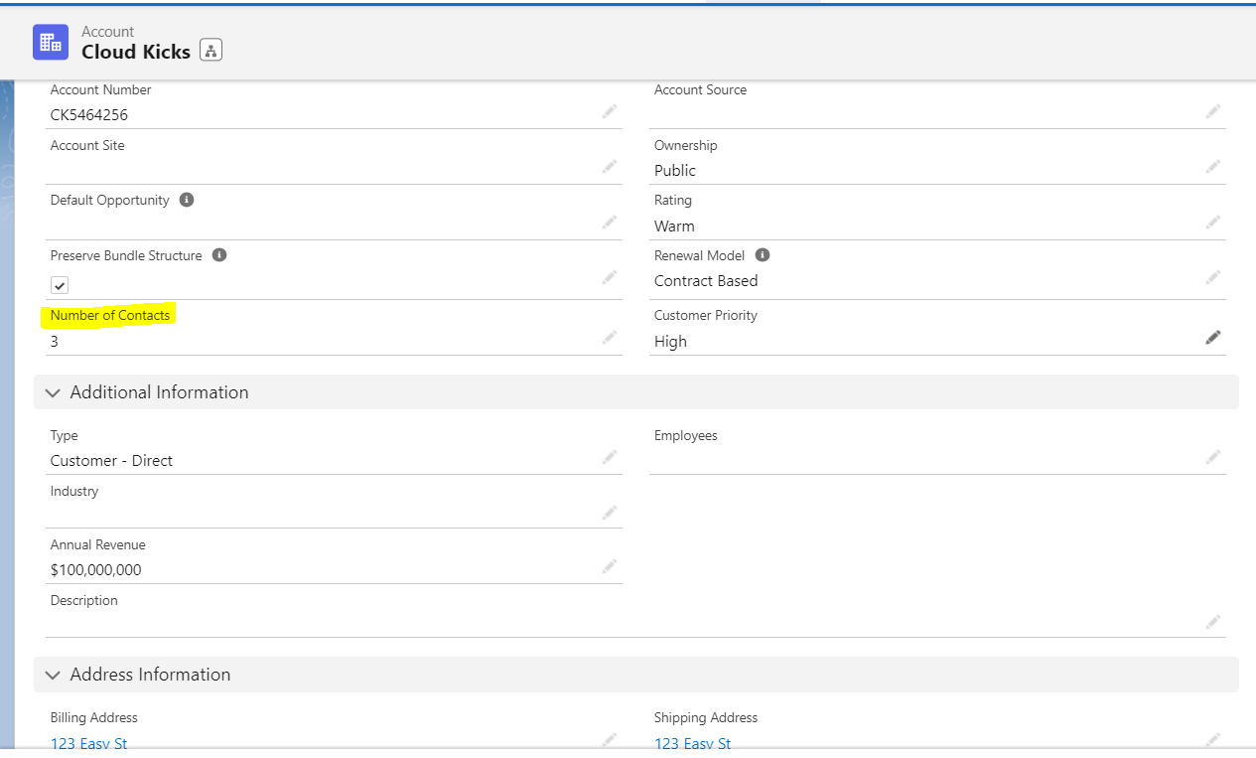

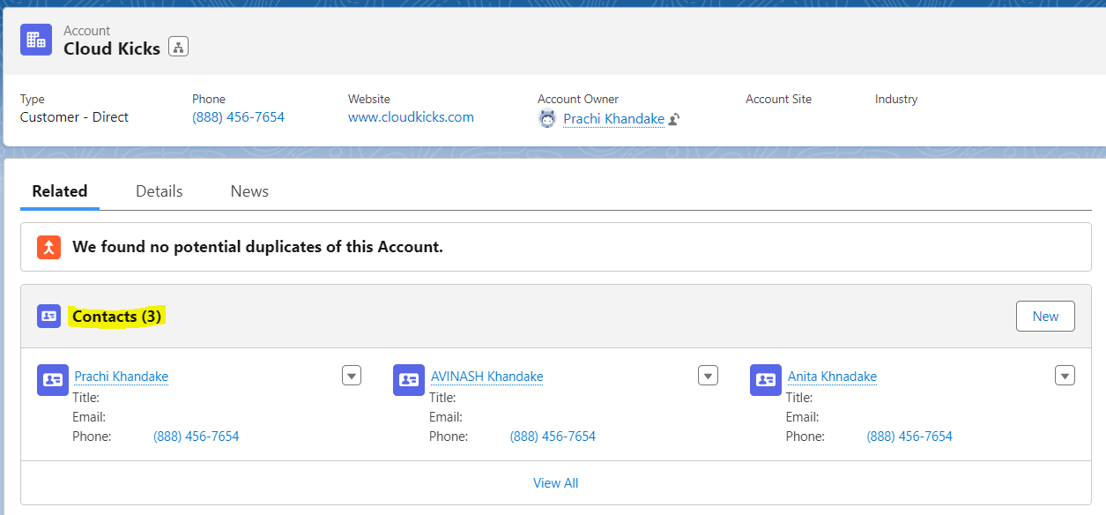

Scenario 2 : After Delete

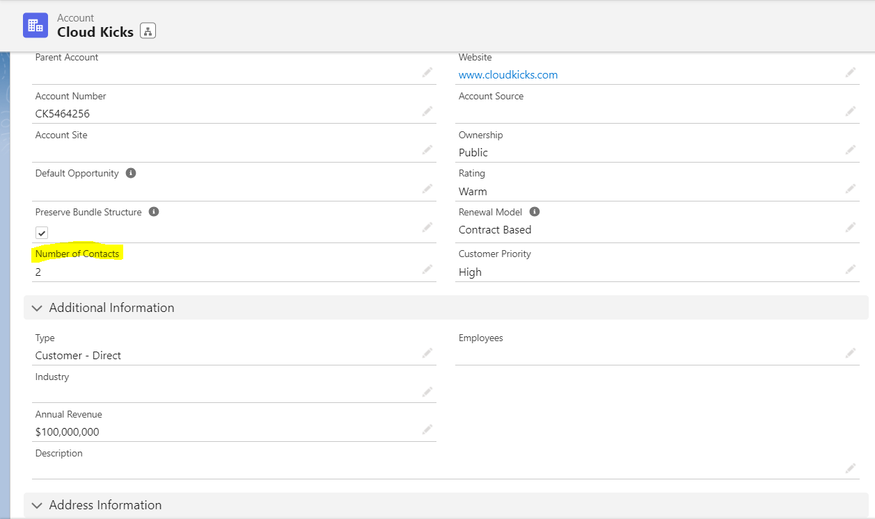

s